**PICKLE RICK**

Platform – TryHackMe

Difficulty – Easy

Link - <https://tryhackme.com/room/picklerick>

Tags - Enumeration, Web Exploitation

Description - This Rick and Morty-themed challenge requires you to exploit a web server and find three ingredients to help Rick make his potion and transform himself back into a human from a pickle.

Tools - gobuster

Commands - ls,less,cd,sudo

Walkthrough

Our goal is to find all the 3 ingredients.

1.Deploy the give IP address in your browser, it will open a webpage

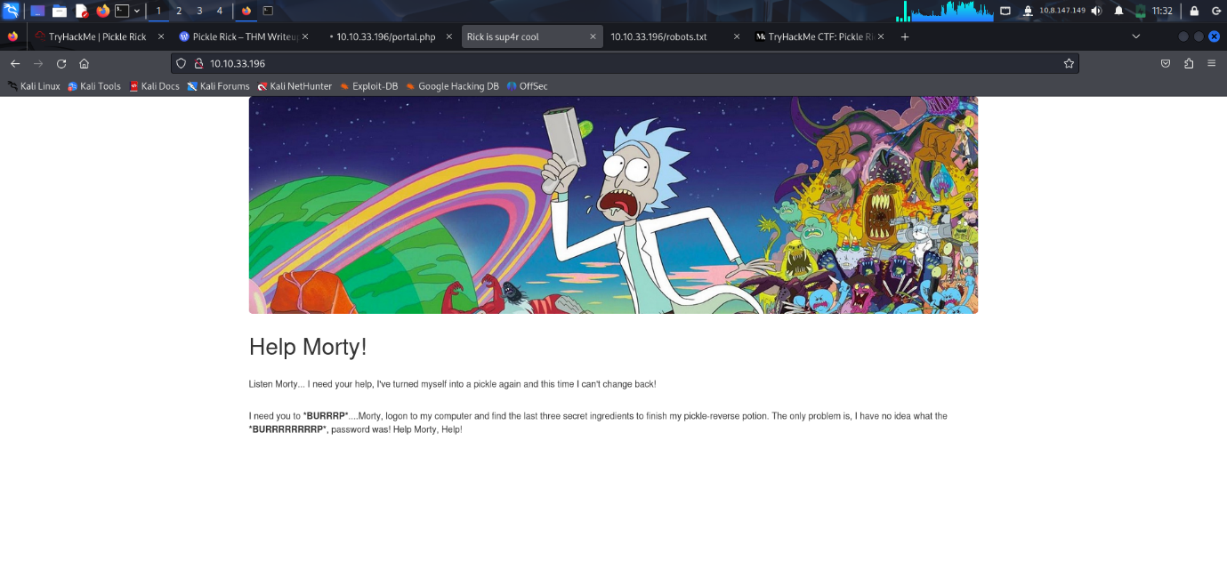

2. View the page source and a login page was mentioned along with a username

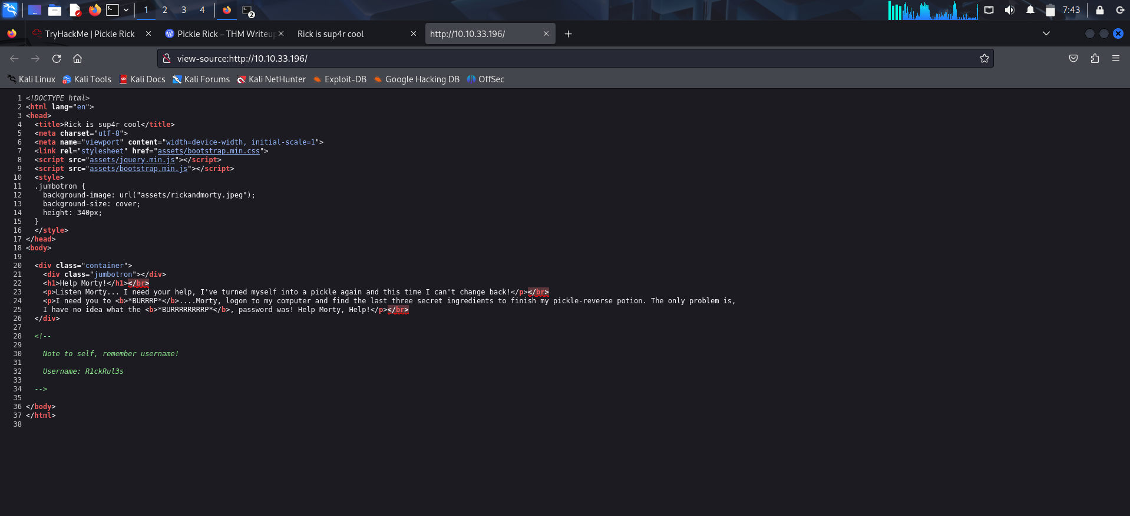

3. Website Enumeration

Using the gobuster tool we will find a login.php page

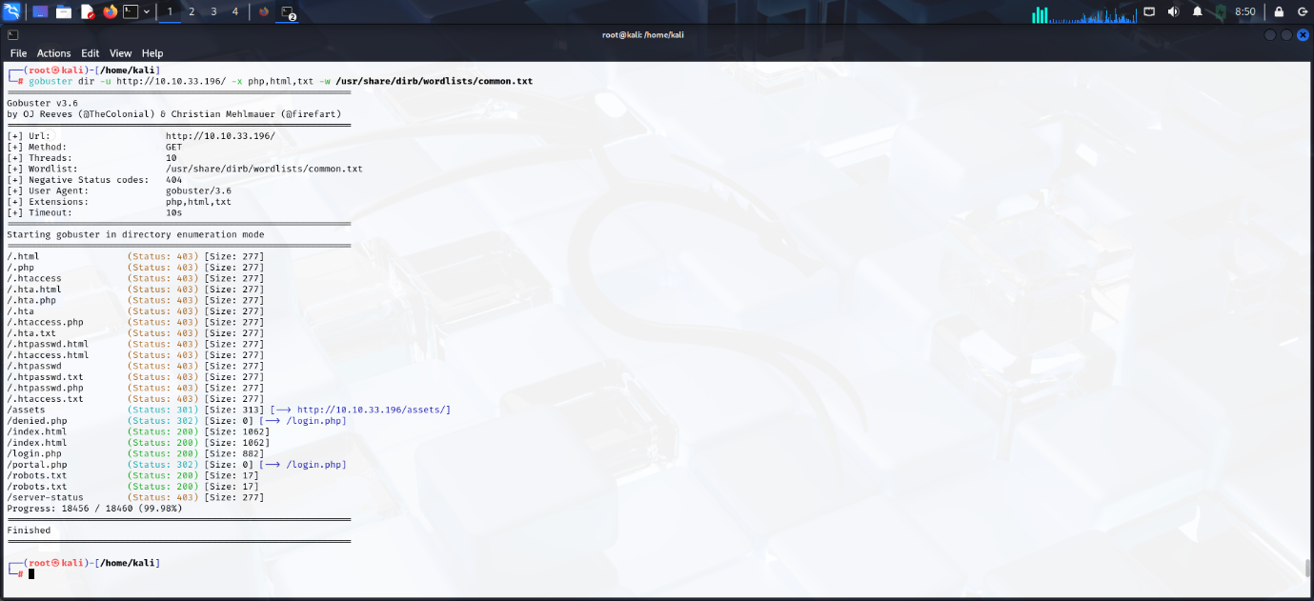

Navigate to the login page and we will see that it requires a password

Go to robots.txt file in the address bar and we will obtain the password

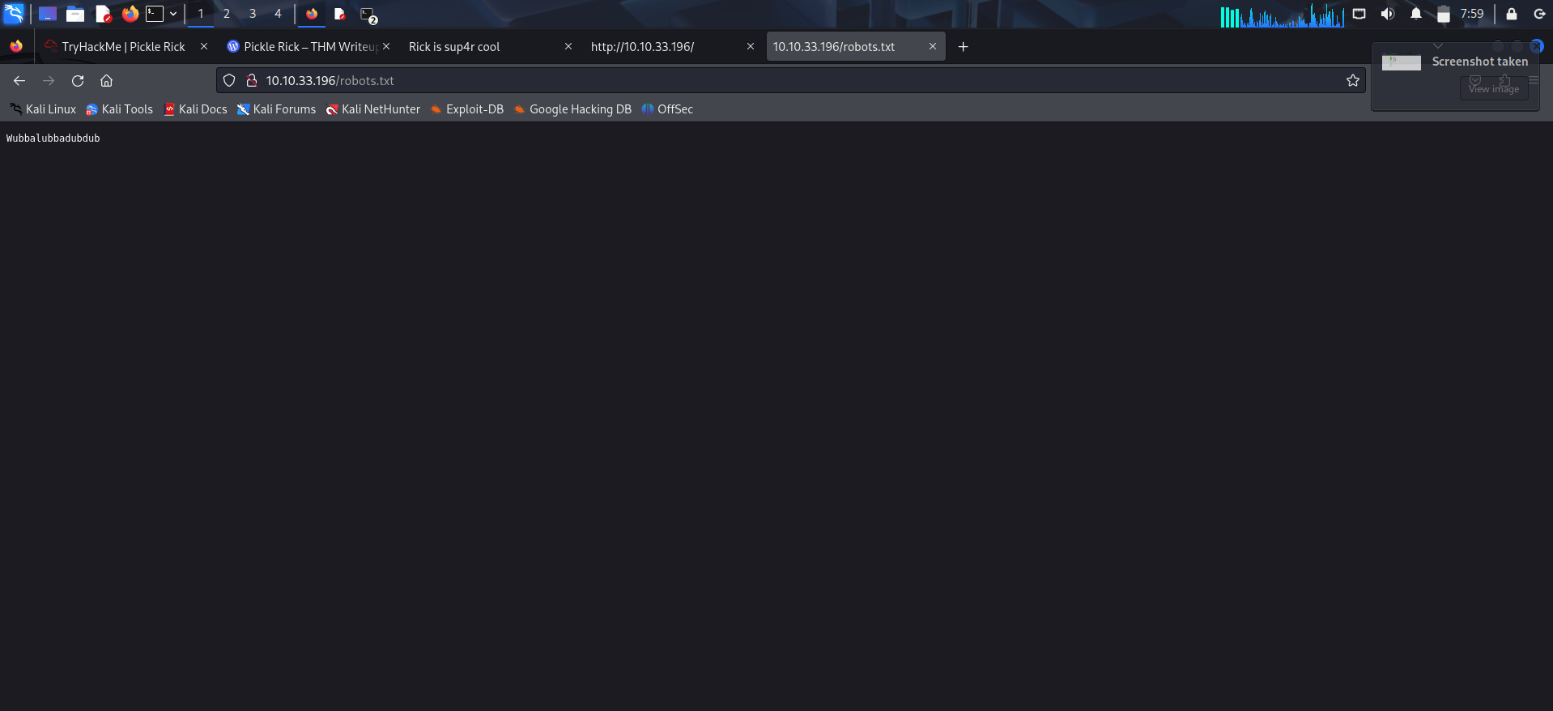

Login into the page using the credentials

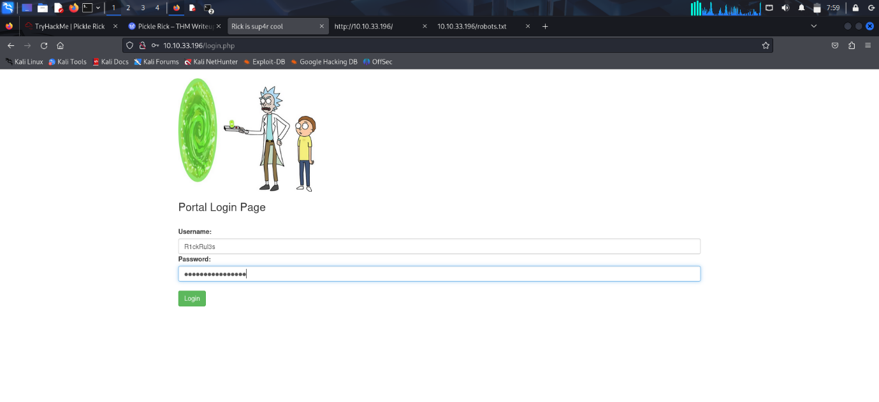

After login a command shell will be present

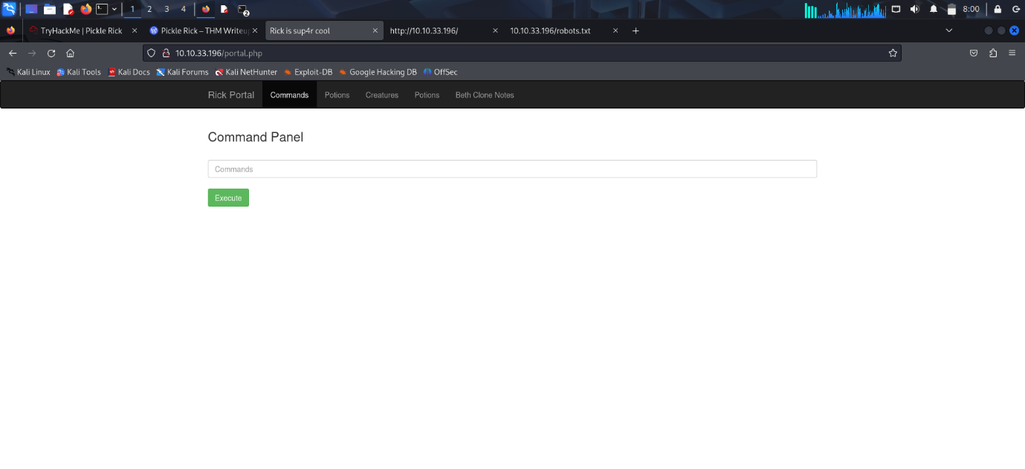

Use the ls command to see the files

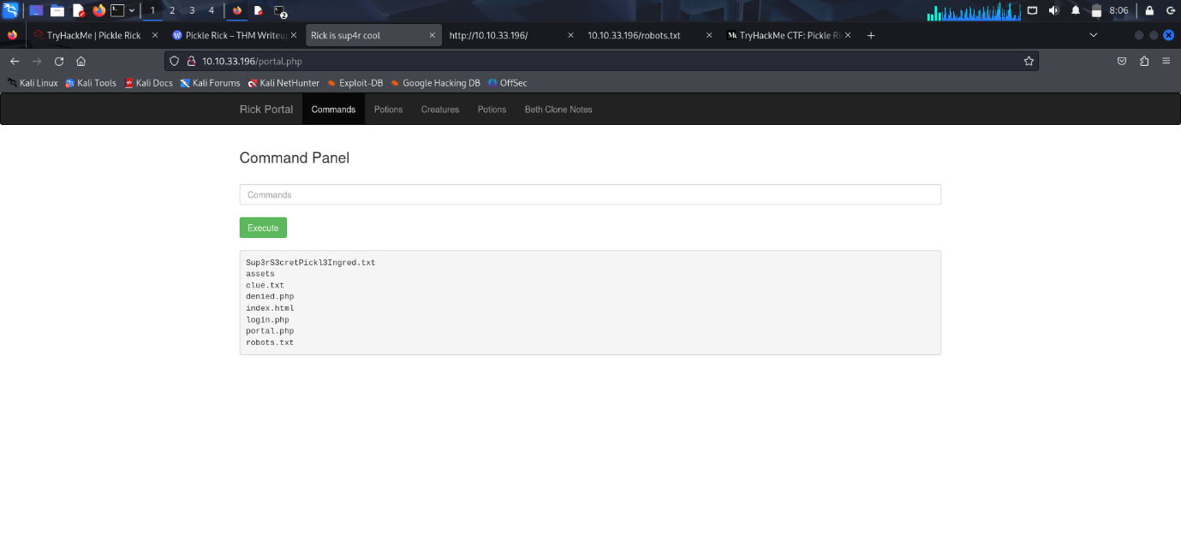

There is a text file named Sup3rS3cretIngred.txt . Use ‘cat’ command to see the contents of the files

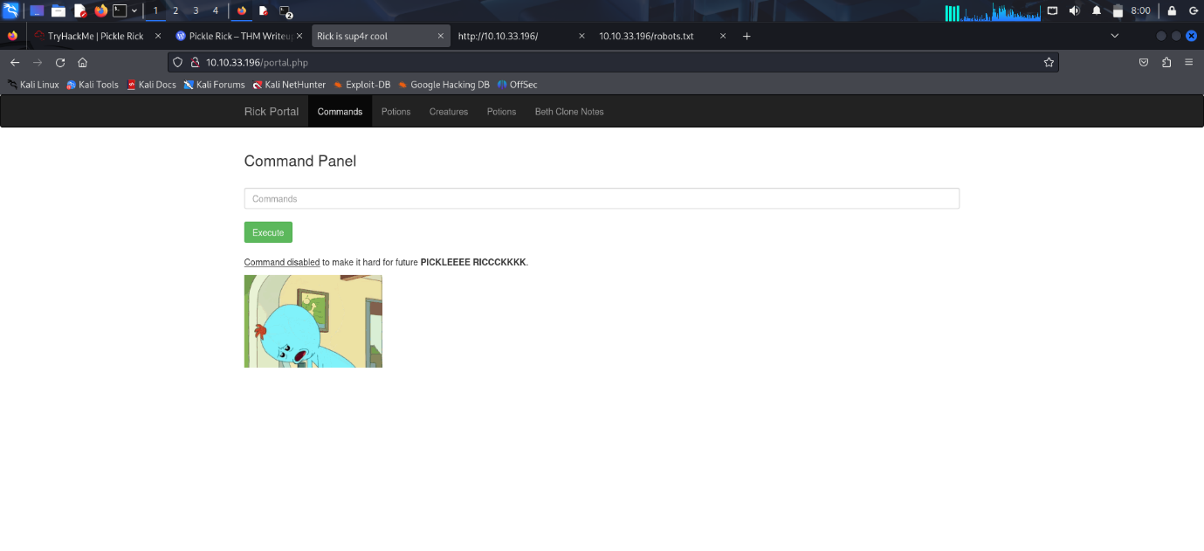

The ‘cat’ command seems to be disabled so use the ‘less’ command

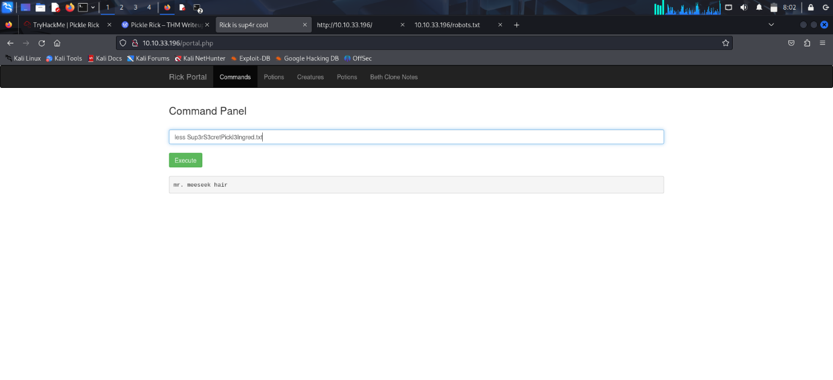

We got the first ingredient – mr. meeseek hair

There was another text named clue.txt





Use ‘less’ command to see the contents of the file

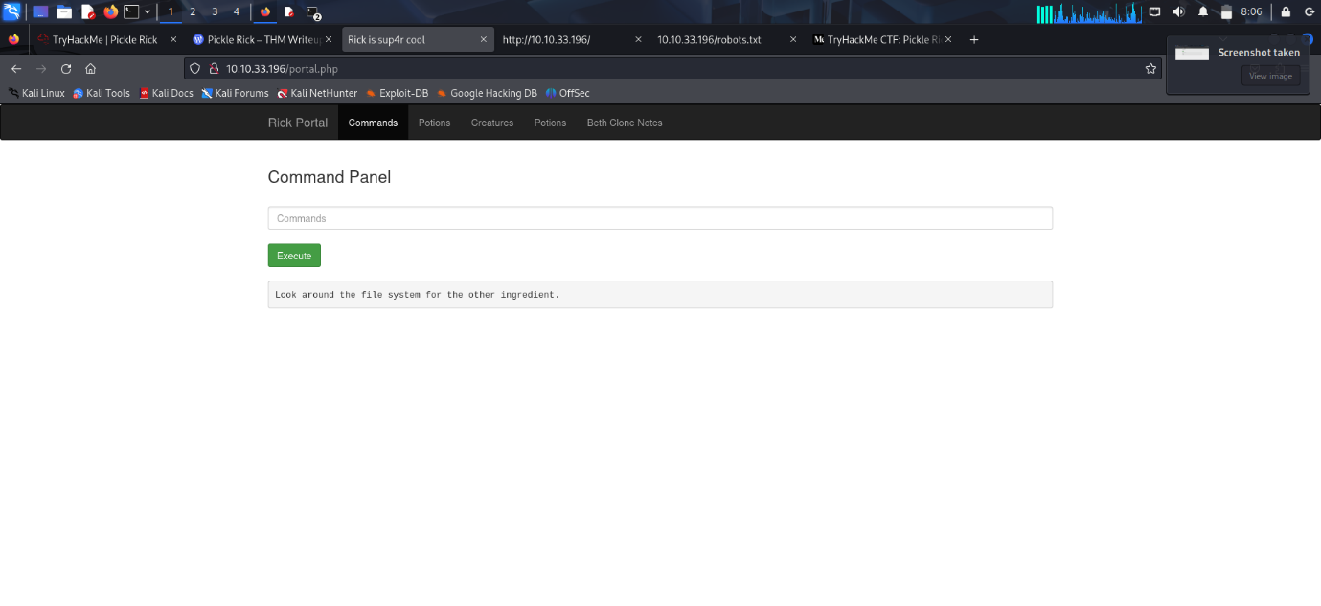

It says that we have to look around the file system for the next clue

Navigate to home using ‘ls /home’ command

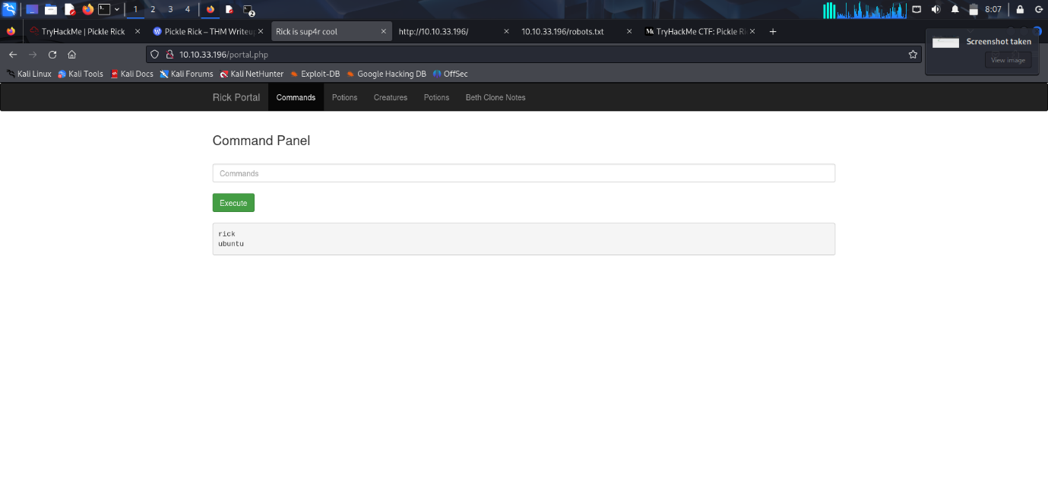

It shows 2 directories ‘ubuntu’ and ‘rick’ . The “ubuntu” directory seems like a default directory on the Linux system itself but the “rick” directory is most certainly a configured user.

Navigate and list all the files inside ‘rick’ directory using ‘ls /home/rick’ command

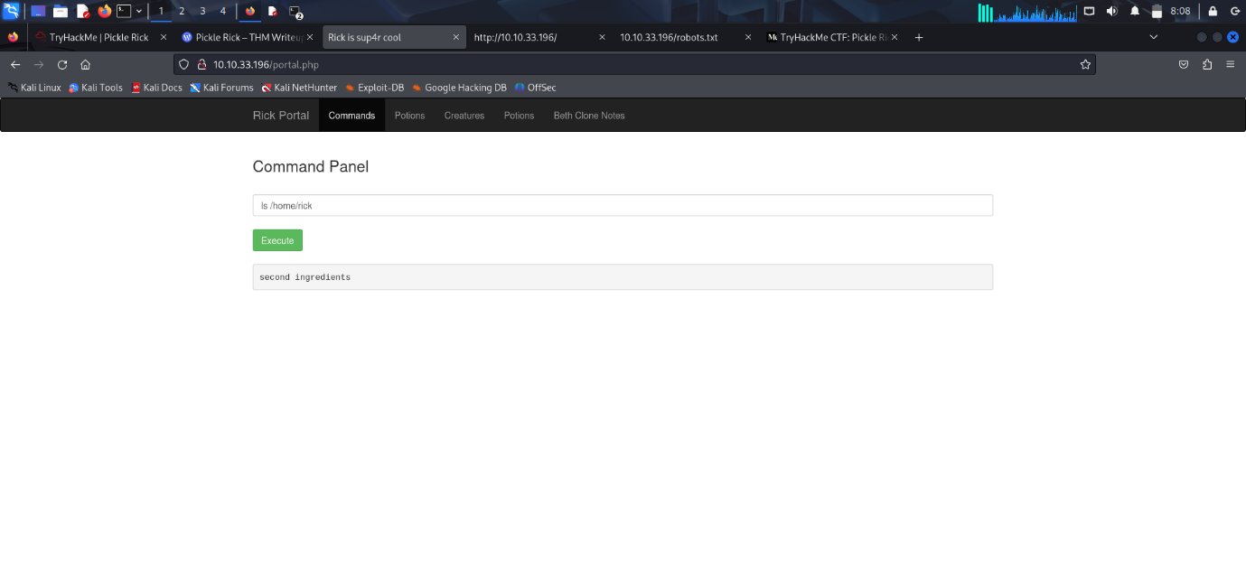

It shows a file named ‘second ingredients’. See the contents of this file using ‘less’ command

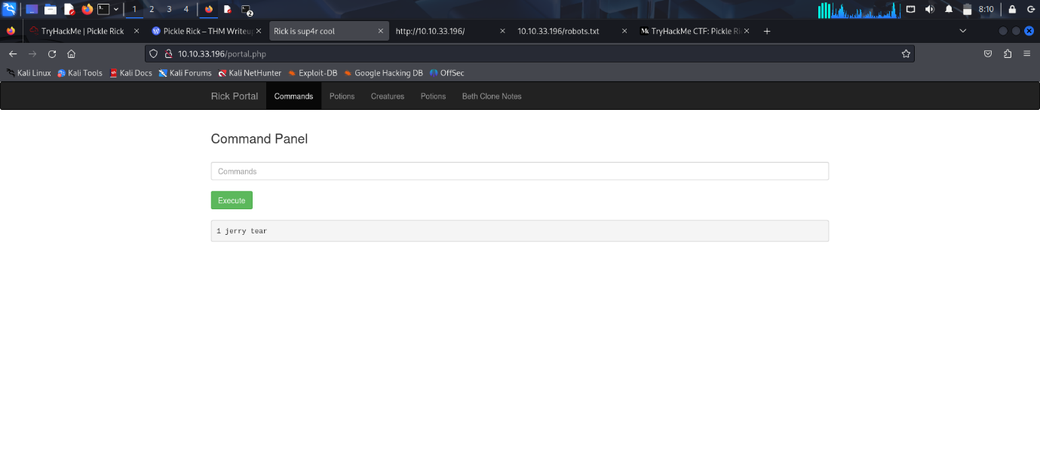

We get the second ingredient ‘1 jerry tear’

For the 3rd ingredient try to access the root directory by using ‘cd /root’ command

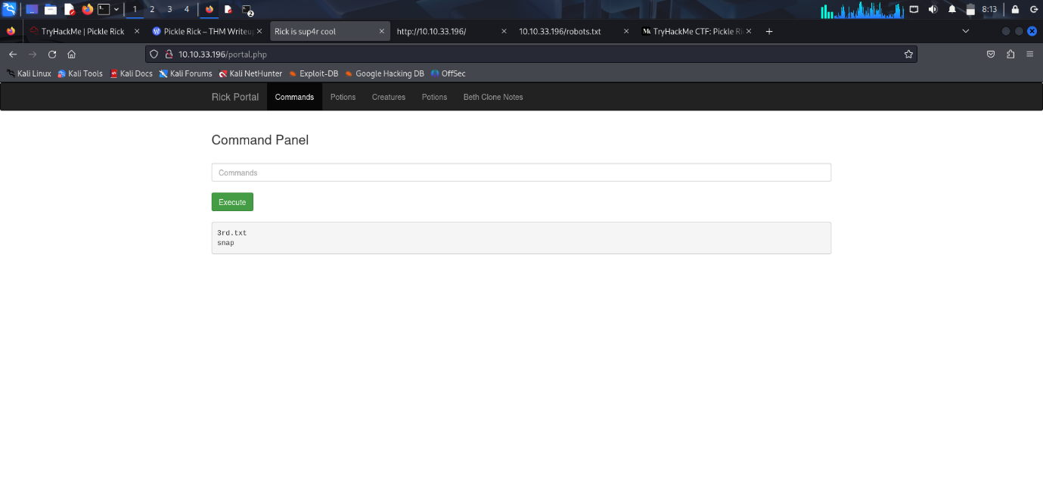

It shows a file named ‘3rd.txt’ . Use the ‘sudo less /root/3rd.txt’ command to see the contents

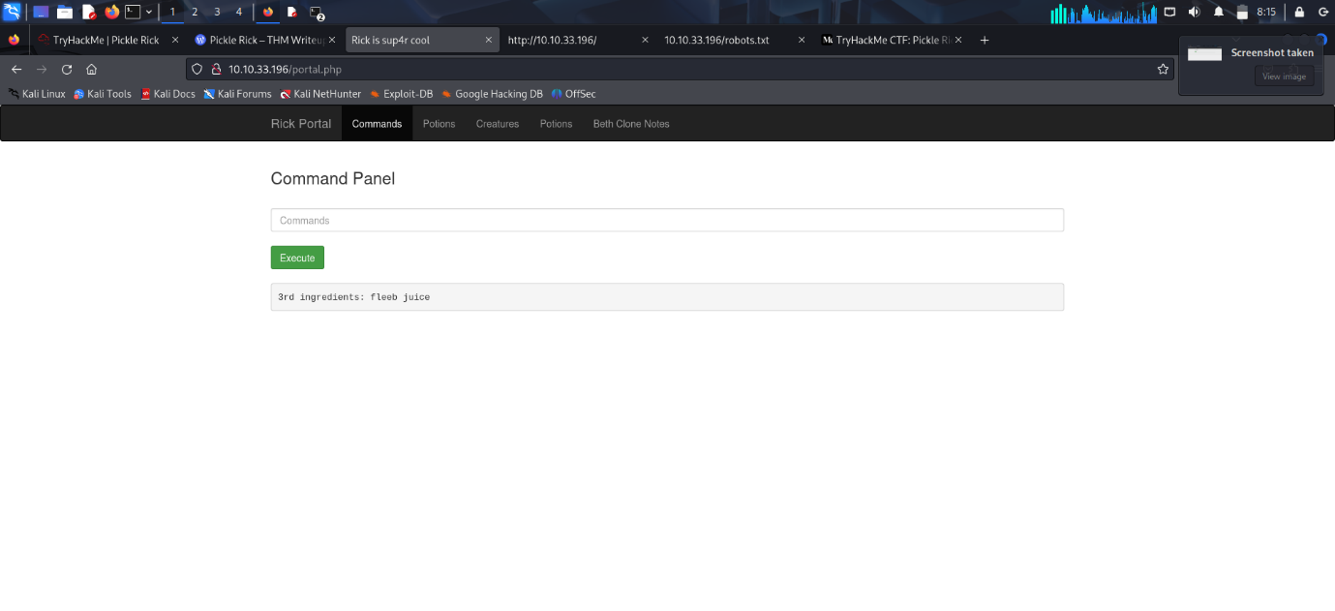

We get the final ingredient ‘fleeb juice’

Conclusion

The Pickle Rick room is a simple and fun challenge for beginners. It helps you learn how to:

* Find hidden pages on a website
* Use easy/default usernames and passwords
* Explore a Linux system using a web shell
* Get root (admin) access by using sudo

We found all three ingredients Rick needed by checking different files on the system.